**6.) What is inheritance and where are you using in your automation?**

- Inheritance is an Object oriented concept where a sub class inherits from the parent class (methods, fields). Inheritance can be applied between classes, interface, as well.

- Inheritance can be achieved by using **extends** keyword.

- The main advantages of using Inheritance is its reusability and maintenance

- There are different types of Inheritance like Single, Multiple, Multi-Level, Hierarchical and hybrid.

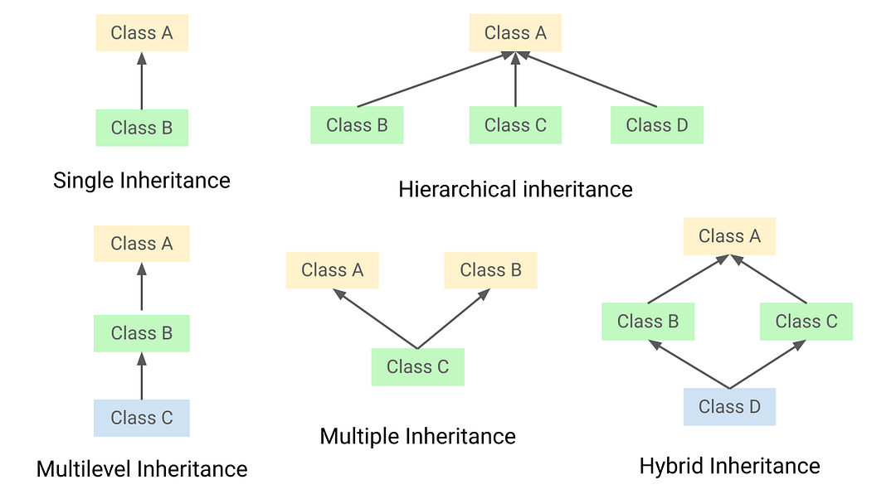

- For Example, reusability is achieved in our framework where we have a class called SeleniumBase which acts as the wrapper class where we have all the reusable methods which is inherited by pages and testcases to use the reusable codes from it.

- In our framework, we have implemented **hybrid** inheritance. It combines both hierarchical and multilevel inheritance to achieve a flexible and reusable structure. It begins with the DriverInstance class, which act as supermost parent class for our test automation framework, where we have driver related configurations to have seamless parallel execution as well. This DriverInstance is inherited by Reporter class, where we have extentReport configuration.

Reporter class is extended by SeleniumBase, which acts as the wrapper class which contains all resuable methods with proper exception handling. SeleniumBase is further inherited by ProjectSpecificMethod, which is the BaseClass for all Pages and testcases. Finally ProjectSpecificMethods is inherited by both Pages and Testcases.

This hierarchy combines both hierarchical and multilevel inheritance, which builds the hybrid inheritance in our framework.

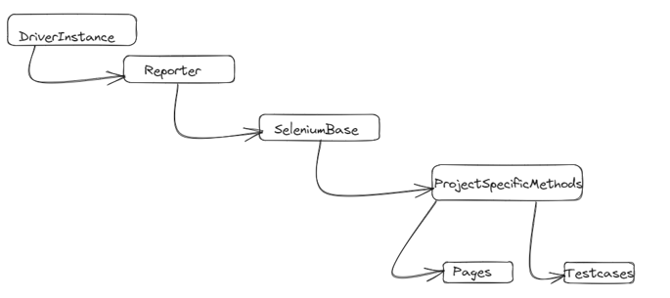

- We've also implemented **multiple inheritance** in the SeleniumBase class, which serves as a crucial component of our framework. This class implements two different interfaces: the Browser interface and the Element interface where the Browser interface provides methods for browser-level interactions, and the Element interface defines methods for interacting with web elements on a page.